The Engduino Pedometer

# Documentation

### How to use the Engduino

In terms of preparing the Engduino for upload, no special libraries have been used, so it will be ready to use with just an upload. The program to be used along with the Engduino is a program written in Processing.

The Engduino is programmed to record your acceleration values automatically when a working SD card is inserted, *and* there is not a USB cable attached linking the device to the computer.

### Using the Processing Program

Once you’re done with all your walking, the next step is to connect the Engduino to the Processing program and upload your data. To do this:

1. Open the program in Processing.
2. Plug in the Engduino to your USB port (it can be off or on).
3. Turn on the Engduino if it wasn’t on already.
4. Start the Processing program.
5. Press the button on the Engduino and it will begin uploading data to processing.
6. When it is done with data upload, the Processing console will read ‘Data upload complete’.

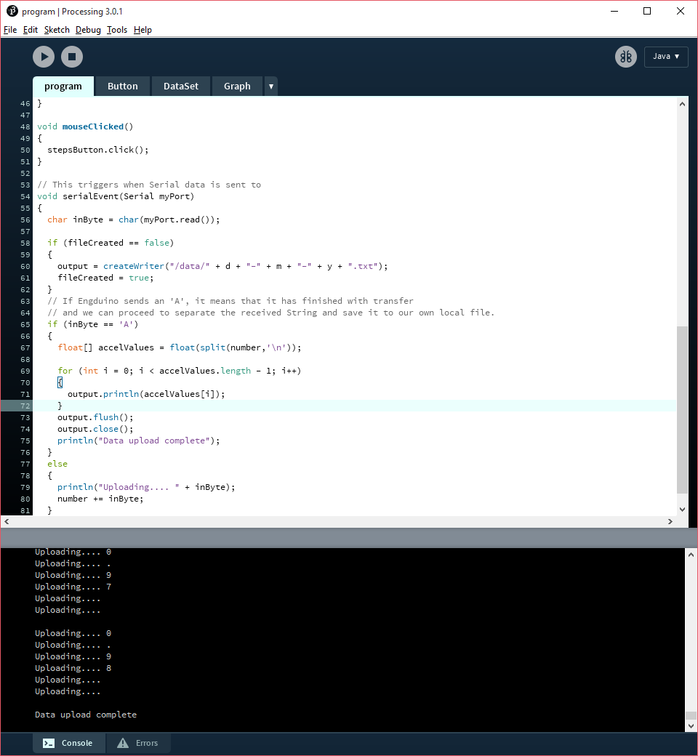

The data uploaded from the Engduino is stored in the .txt files in the /data/ directory. Each day you upload data from the Engduino, a new .txt file will be create to store your new data for a new day.

If you click on the step button, the program will apply a low-pass filter over the data to filter out the high frequency noise, and calculate the number of steps you have taken for the day.

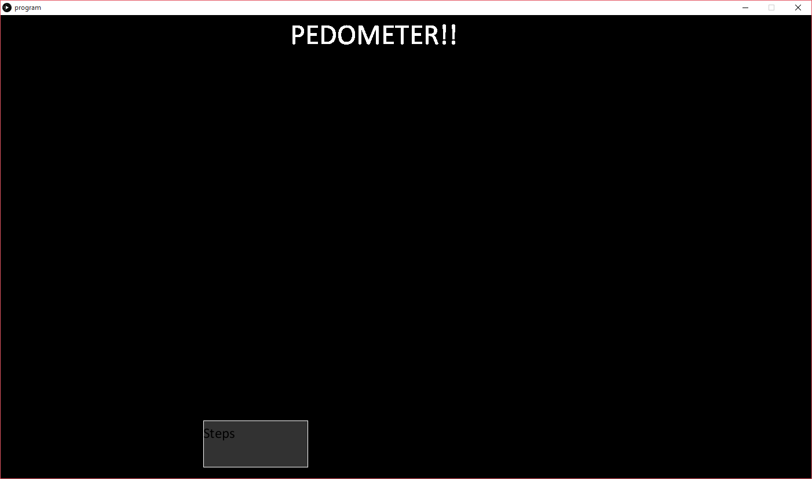

Click

Each day of data uploads will count as a datapoint, and the program will automatically scale to fit more days as you keep uploading data.

If you’re that devoted to using the Engduino as a pedometer, one day the data display may get a bit crowded so you’ll have to move some data away, or deal with it.

A small set of sample data has been included to give an idea of how the data display would work after a few days.

P.S. Use the case to keep the Engduino safe in your pocket.